JWG – proposal
ANNEX

to the

Implementing Act on interoperability requirements and non-discriminatory and transparent procedures for access to and exchange of data for customer switching

The reference model for the customer switching process
The reference model for a customer switching process, the switching of supplier, is composed of a set of reference procedures for access to data and of the required information exchanges between roles played by market parties relating to this specific case.
The tables in this Annex reflect sets of information that constitutes the reference model. The procedural steps that are set out in this Annex may be combined or carried out in a different order when applied at the national level.

Table I and Table II must be read in conjunction to Table I 'General information on Member States environment' and Table II ‘Roles’ in Annex to the Commission Implementing Regulation (EU) 2023/1162. Table I contains information regarding the national market structure and environment for which final customers will benefit and also energy suppliers that would like to set up their operations in the respective territory in each Member State. Table I is primarily listing information that needs to be accessible for the final customers to choose new supplier and for energy suppliers to register, on-board or establish prerequisite infrastructure to take part in the procedures listed in Table III and accordingly communicate and exchange information with relevant market players occupying the roles and undertaking the responsibilities indicated in Table II.

Table I – Additional general information on Member State environments
ID | Name |  | Description
I1 | Information about energy suppliers in a Member State |  | Name |  | Name of the organisation, which is responsible for registering and publishing information about active energy suppliers in a publicly available register in the Member State.
 |  |  | Type of identification of energy suppliers in the register |  | ACER registration code, Legal Entity Identifier (LEI), Energy Identification Code (EIC), Global Location Number (GLN/GS1) or National Identification Code (NIC).
 |  |  | Website |  | If applicable, link to the website that is used to publish information about active energy suppliers in the Member State.
 |  |  | Official contact |  | Contact details of the entity responsible for registering and publishing information about active energy suppliers in the Member State.
I2 | Information about balance responsible parties in a Member State |  | Name |  | Name of the organisation, which is responsible for registering and publishing information about active balance responsible parties in a publicly available register in the Member State.
 |  |  | Type of identification of balance responsible parties in the register |  | ACER registration code, Legal Entity Identifier (LEI), Energy Identification Code (EIC), Global Location Number (GLN/GS1) or National Identification Code (NIC).
 |  |  | Website |  | If applicable, link to the website that is used to publish information about active balance responsible parties in the Member State.
 |  |  | Official contact |  | Contact details of the entity responsible for registering and publishing information about active balance responsible parties in the Member State.

 |  | Table II.1 – Additional roles
Role name | Role type | Role description
Balance responsible party | Business | A balance responsible party is a market participant or its chosen representative responsible for its imbalances in the electricity market as defined in point (14) of Article 2 of Regulation (EU) 2019/943.
Energy supplier | Business | An energy supplier is a market participant engaged in energy supply.

 |  | Table II.2 – Aggregated roles
 |  | Aggregated roles contain eligible parties – as defined in point (6) of Article 2 of Regulation (EU) 2023/1162 - who are performing a specific service for the accounting point involved that is impacted by the execution of the procedures in Table III. The aggregated role can be assigned to one or more eligible parties based on national rules of the Member State. However, every party that is assigned aggregated role plays this role on its own responsibility.
Role name | Role type | Role description
Affected party | Business | This role gains or loses responsibility for the accounting point involved as a direct consequence of the switching supplier or the cancellation of switching supplier process.
Entitled party | Business | This role should be informed about the changes made in the metering point register by the metering point administrator as consequence of the switching supplier or cancellation of switching supplier process.

All roles of type Business are expected to be acting in secure, authenticated manner and through trusted communication channels. For this reason, the authentication steps used for these communication partners are not listed in the procedures listed below. These are the procedure ‘switching supplier’ and the optional procedure ‘cancellation of switching supplier’.

Table III – Procedure Conditions
No. | Procedure name | Primary actor | Pre-conditions
1 | Switching supplier | Final customer | - The new supplier is registered as energy supplier  - The new supplier has authenticated the final customer details  - The new supplier has identified the accounting point  - The new supplier has permission of the final customer, provision of authorisation can be provided by use of permission administrator
2 | Optional procedure  Cancellation of switching supplier | Final customer | - The final customer has a supply contract with the (new) supplier  - The supply of electricity based on the new contract has not yet started

Where Article 23 (1) of Directive (EU) 2019/944 mentions customer switching in this Regulation it is understood as the switching of supplier by the final customer. The scope of this Annex is the overall core procedures for switching supplier (Table III.1) and 'cancellation of switching supplier’ (Table III.2).
All procedures represent the “happy flow” specifying the successful execution of the process.

The procedure ‘switching supplier’, as detailed in Table III.1, includes the registration of the new supplier on the accounting point according to the date specified in the supply contract. The actual registration of the new energy supplier, as shown in procedure step 1.15 in Table II, is done by the metering point administrator in the metering point register.

The optional procedure ‘cancellation of switching supplier’ is used to revoke the supplier switch notification made by the use of ‘switching supplier’ procedure. This procedure is not mandatory in all Member States as it is dependent on national rules for implementations of the final customer’s right to cancel the new supply contract within the allowed regret period.

As shown in Table IV, the information objects exchanged in procedure 1 in Table III.1 and in procedure 2 in Table III.2 are identified with a unique reference. Table IV lists the information objects and for each of them provides descriptions of information exchanged.

The business partners in the process – parties linked to the accounting point – are sometimes differentiated by their direct or indirect interest in the change of supplier. The affected parties are parties whose interests and/or activities are directly affected by the change, whereas the activities of the entitled parties are not necessarily affected.

All diagrams describing the scenarios are of an illustrative nature and follow Business Process Model and Notation 2.0.

Table III.1 – Procedure 1
Procedure name |  | Switching supplier
Step No. | Step | Step description | Information producer (actor) | Information receiver (actor) | Information exchanged (IDs)
1.1 | Contact new supplier | The final customer contacts a potential new supplier in order to obtain an offer which may lead to a new contract for the supply of energy and the possible ending of the contract with the present supplier. | Final customer | New supplier | A
1.2 | [Optional]  Check for possible contractual obstructs | Depending on national rules, the new supplier will check for possible contractual obstructions with the current supply contract that could occur when the new supply contract is activated. | New supplier | New supplier | [not relevant]
1.3 | [Conditional – if step 1.2 is implemented]  Solve issues with present supplier | The new supplier distributes – on authorization of the final customer – the needed information to solve issues with the present supplier  for activation of the new supply contract. | New supplier | Present supplier | [not relevant]
1.4 | [Conditional – if step 1.2 is implemented]  Send issues results | The present supplier informs the new supplier of the issues results | Present supplier | New supplier | [not relevant]
1.5 | [Conditional – if step 1.2 is implemented]  Inform final customer of results | The new supplier informs the final customer of the result. | New supplier | Final customer | B
1.6 | Validate need for accounting point characteristics | The new supplier decides whether he needs upfront metering point characteristics | New supplier | New supplier | [not relevant]
1.7 | [Optional]  Request upfront accounting point characteristics | The new supplier- having permission of the final customer – requests the upfront accounting point characteristics from the metering point administrator | New supplier | Metering point administrator | C
1.8 | [Conditional – if step 1.7 is implemented]  Validate upfront accounting point characteristics request | The metering point administrator validates the upfront accounting point characteristics request | Metering point administrator | Metering point administrator | [not relevant]
1.9 | [Condition – if step 1.7 is implemented]  Send accounting point characteristics | The metering point administrator sends the requested accounting point characteristics to the new supplier or provides a meaningful indication in case of an invalid request. | Metering point administrator | New supplier | D
1.10 | [Conditional – if step 1.7 is implemented]  Inform final customer of accounting point validation results | The new supplier informs the final customer of the accounting point validation result. | New supplier | Final customer | B
1.11 | Request switch of supplier | The new supplier requests to be registered in the metering point register as the new supplier (together with its balance responsible party) for the accounting point per requested date. | New supplier | Metering point administrator | E
1.12 | Check switch of supplier request | The metering point administrator validates the specified switch supplier request | Metering point administrator | Metering point administrator | [not relevant]
1.13 | Send switch of supplier request results | The metering point administrator sends the validation result of the requested change of supplier at the accounting point. In case of an invalid request a meaningful indication is provided. | Metering point administrator | New supplier | F
1.14 | Inform final customer of supplier switch results | The new supplier informs the final customer of the supplier switch result. | New supplier | Final customer | B
1.15 | Notify affected parties of supplier switch | The metering point administrator notifies all affected parties directly after positive validation of the switch of supplier request | Metering point administrator | Affected party  (Table II roles) | H
1.16 | Registration in metering point register | The metering point administrator registers a new supplier (together with its balance responsible party) in the metering point register as the new supplier for the accounting point per specified date. The metering point administrator makes all necessary updates for the switch of supplier. | Metering point administrator | Metering point administrator | [not relevant]
1.17 | Notify accounting point characteristics to entitled parties | Entitled parties receive updated accounting points characteristics due to the switch of supplier registration process at the specified date of the change of supplier | Metering point administrator | Entitled party (Table II roles) | G
1.18 | [Optional]  Request meter read | New supplier requests a meter read for the effective date of the change of supplier on the accounting point. | New supplier | Metered data administrator | Regulation (EU) 2023/1162 – ANNEX  Table IV (C)
1.19 | [Conditional - if step 1.18 is implemented]  Validate meter read request | The metered data administrator validates the meter read request. | Metered data administrator | Metered data administrator | [not relevant]
1.20 | [Conditional - if step 1.18 is implemented]  Send meter read | The metered data administrator sends the requested meter read to the new supplier and provides a meaningful indication in case of an invalid request. | Metered data administrator | New supplier | Regulation (EU) 2023/1162 – ANNEX  Table IV (E)

Diagram 1 – Procedure ‘Switching supplier’

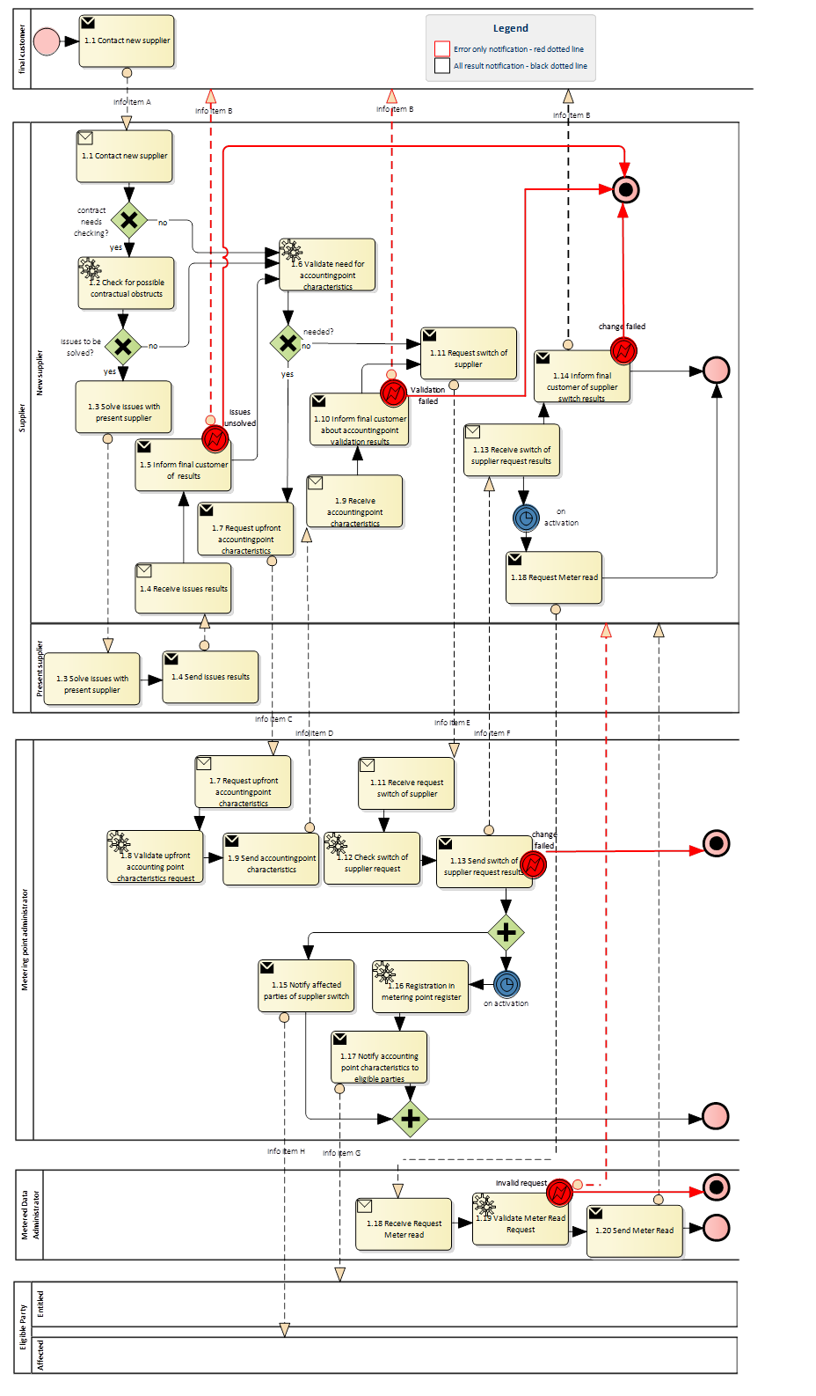

Table III.2 – Optional procedure 2
Procedure name |  | Cancellation of switching supplier
Step No. | Step | Step description | Information producer (actor) | Information receiver (actor) | Information  exchanged (IDs)
2.1 | Request cancellation of new supply contract | Final customer requests cancellation of the new supply contract to the newly contracted supplier | Final customer | New supplier | J
2.2 | Validate request | The new supplier validates:  - the existence of the contract with the final customer for the accounting point  - the cancellation request is before start data of supply in the new contract.  . | New supplier | New supplier | [not relevant]
2.3 | Notify on validation failure | The final customer is notified on validation failure with a meaningful indication. | New supplier | Final customer | B
2.4 | Validate registration new supplier on accounting point | The new supplier validates the registration of the switch of supplier request in the metering point register based on new contract | New supplier | New Supplier | [not relevant]
2.5 | Request cancellation of new contract in the metering point register | The new supplier requests to cancel the pending switch of supplier in the metering point register due to cancellation of the new supply contract | New supplier | Metering point administrator | K
2.6 | Validate cancellation request | The metering point administrator checks if the new supplier is registered at the accounting point for supply on start date of the new contract | Metering point administrator | Metering point administrator | [not relevant]
2.7 | Inform on validation result | The metering point administrator informs the new supplier of the validation results and in case of an invalid request, he provides a meaningful indication. | Metering point administrator | New supplier | M
2.8 | Cancel the pending switch of supplier | The metering point administrator cancels the pending switch of supplier registration | Metering point administrator | Metering point administrator | [not relevant]
2.9 | Notify cancellation of switch of supplier to affected parties | The metering point administrator notifies the affected parties of the cancellation of the switch of supplier. | Metering point administrator | Affected parties | L
2.10 | Send information on validation failure | The new supplier informs the final customer on the validation failure with a meaningful indication. | New supplier | Final customer | B
2.11 | Cancel contract | The new supplier cancels the supply contract with the final customer. | New supplier | New supplier | [not relevant]
2.12 | Notify final customer of cancellation of contract | The final customer is notified by the new supplier of cancellation of the new supply contract. | New supplier | Final customer | N

Diagram 2 – Optional procedure ‘Cancellation of switching supplier’
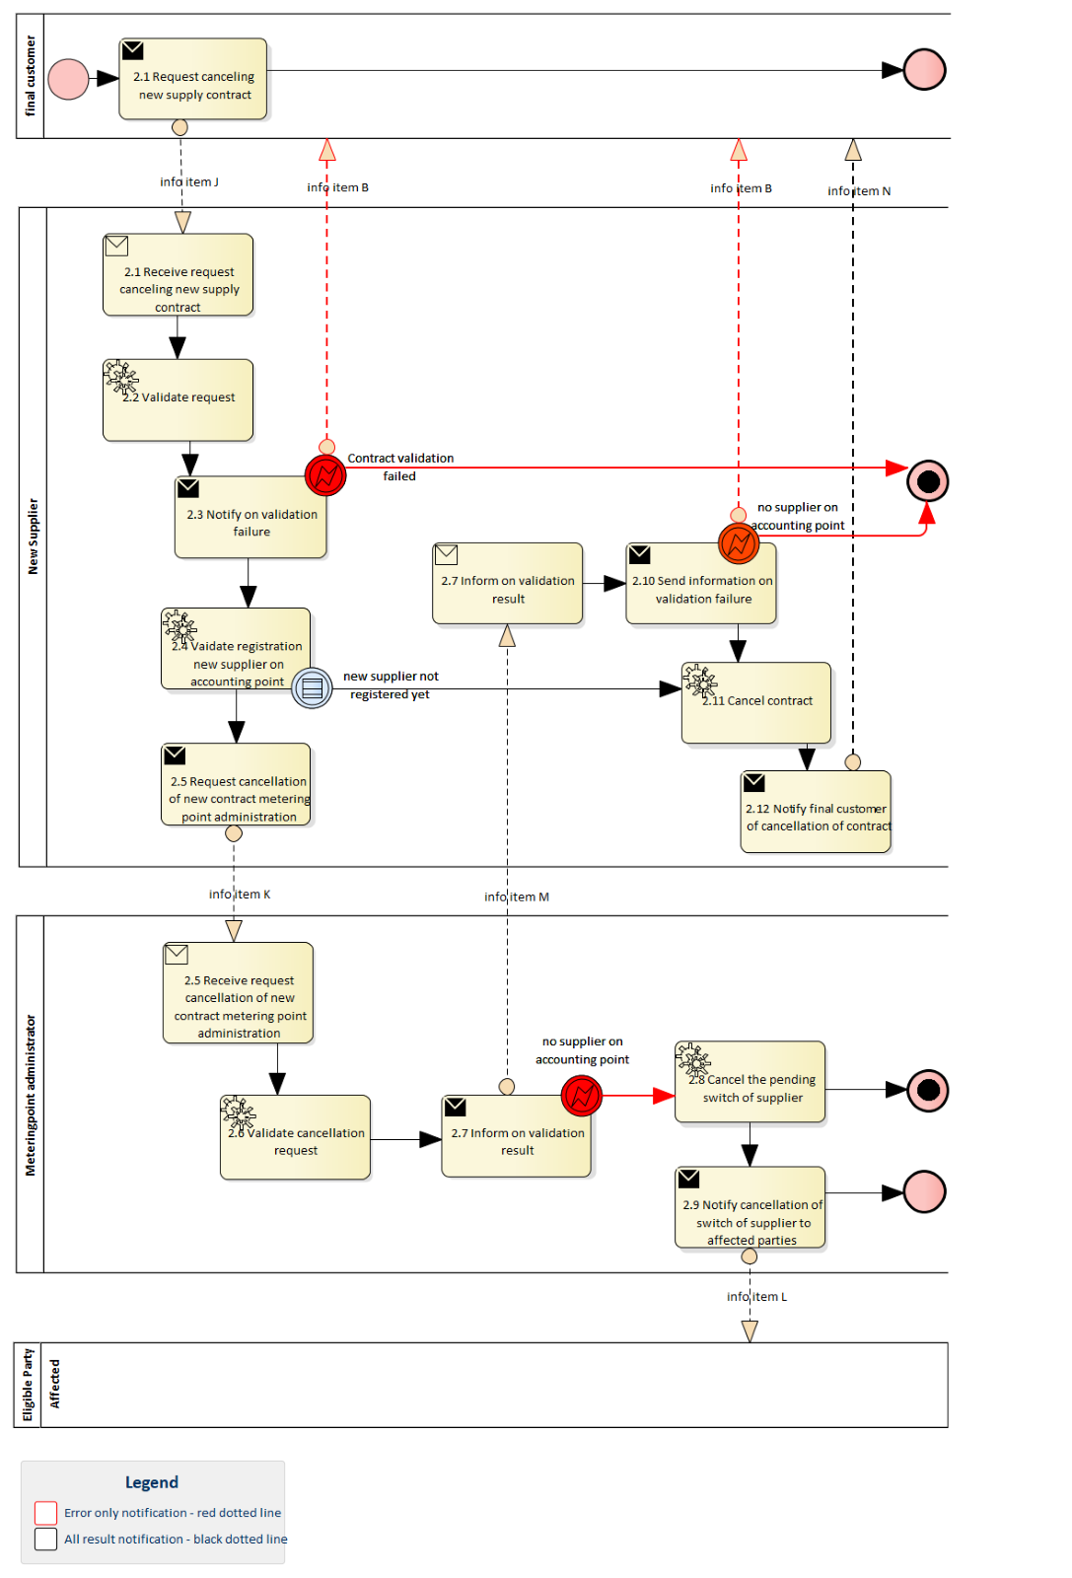

TABLE IV – Information objects exchanged
Information exchanged ID | Name of information | Description of information exchanged |  | Remarks
A | Contact new supplier | Accounting point identifier | Information set to identify the accounting point
 |  | Final Customer | Information set to identify final customer
 |  | Requested start date | Requested date by the final customer for start of supply
B | Inform customer on validation result | Validation result | Information about the outcome of the validation step
C | Upfront accounting point characteristics request | Accounting Point ID | The unique identification of the accounting point the switch of supplier is requested for.
 |  | Requesting Party ID | The unique identification of the requesting party (= new supplier) that intends to supply the accounting point.
 |  | Request reason | A code specifying the reason (= switch of supplier) for the request.  The code is not specified in the Implementing Regulation, to be described in business standardisation.
D | Upfront accounting point characteristics | Start date | The date when the content of this set of information becomes or became valid. | Only a minimal set of attributes is defined, further  specification of this information object will be left to national implementation of the Member State.
 |  | Accounting Point ID | The unique identification of the accounting point.
 |  | Future Supplier | Indicates if there is a contract for a future supplier at this accounting point. The element is boolean (yes or no).
 |  | Future supply start date | Date on which future supply will start
E | Request switch of supplier | Start date | The date requested by the new supplier to take over the energy supply for this accounting point. This date must be in the future
 |  | Accounting Point ID | The unique identification of the accounting point this request switch of supplier is aimed for.
 |  | New supplier ID | The unique identification of the requesting supplier.
 |  | New Balance Responsible ID | The unique identification of the balance responsible party or balancing group for this accounting point, as requested by the new supplier.
 |  | Final Customer | Information set to identify final customer
F | Switch of supplier results | Reason rejection | {if rejected} A code specifying (one of) the reason(s) for the rejection of the requested switch of supplier.  The codes are not specified in the Regulation, to be described in business standardisation.
G | Notify accounting point characteristics to entitled parties | Start date | The date from when the new supplier and balance responsible party start the supply or balance responsibility for this accounting point. | Only a minimal set of attributes is defined, further  specification of this information object will be left to national implementation of the Member State.
 |  | Accounting Point ID | The unique identification of the accounting point the switch of supplier is confirmed for.
 |  | Supplier ID | The unique identification of the supplier that is supplying the accounting point from the start date
 |  | Balance Responsible Party ID | The unique identification of the balance responsible party or balance group that assumes balance responsibility from the start date for this accounting point.
H | Notification switch of supplier to affected party | Switch date | The date on which the present affected party no longer has the supply or balance responsibility for this accounting point (LOSS) or the data on which the new affected party will have the supply or balance responsibility for this accounting point (GAIN) | There are two versions (GAIN / LOSS) of this information object based on the role of the receiving party (present / new affected party)
 |  | Accounting Point ID | The unique identification of the accounting point the switch of supplier is notified for.
J | Request cancellation of contract | No definition, free format
K | Request cancel switch of supplier metering point register | Start date | The date on which the new supplier was to take over the energy supply for this accounting point. This date must be in the future
 |  | Accounting Point ID | The unique identification of the accounting point the request switch of supplier was aimed for.
 |  | New supplier ID | The unique identification of the requesting supplier.
L | Notification on cancellation switch of supplier in metering point register to affected parties | Start date | The date from which the new supplier was to take over the supply for the accounting point
 |  | Accounting Point ID | The unique identification of the accounting point the switch of supplier is notified for.
M | Notification on cancellation to supplier | Start date | The date on which the new supplier was to take over the energy supply for this accounting point. This date must be in the future
 |  | Accounting Point ID | The unique identification of the accounting point this request switch of supplier is aimed for.
 |  | New supplier ID | The unique identification of the requesting supplier.
 |  | New Balance Responsible ID | The unique identification of the balance responsible party or balance group for this accounting point, as requested by the new supplier.
N | Notification of cancellation of switch of supplier to final customer | No definition, free format

Table II – additional roles must be read in conjunction to (EU) 2023/1162
Business Process Model and Notation 2.0: https://www.omg.org/spec/BPMN/2.0.2/PDF
The purpose for this information object is to provide – on permission- additional accounting point characteristics for the energy supplier to be able to provide tailor-made supply contract proposals for the final customer

